**HR ANALYTICS**

**Introduction:**

Let's dive into the realm of HR analytics using the Employee Dataset from Kaggle. This dataset encapsulates the essence of an organization, offering valuable insights into the trends, statistics, and attrition narratives of a vibrant workforce

**My Dashboard:**

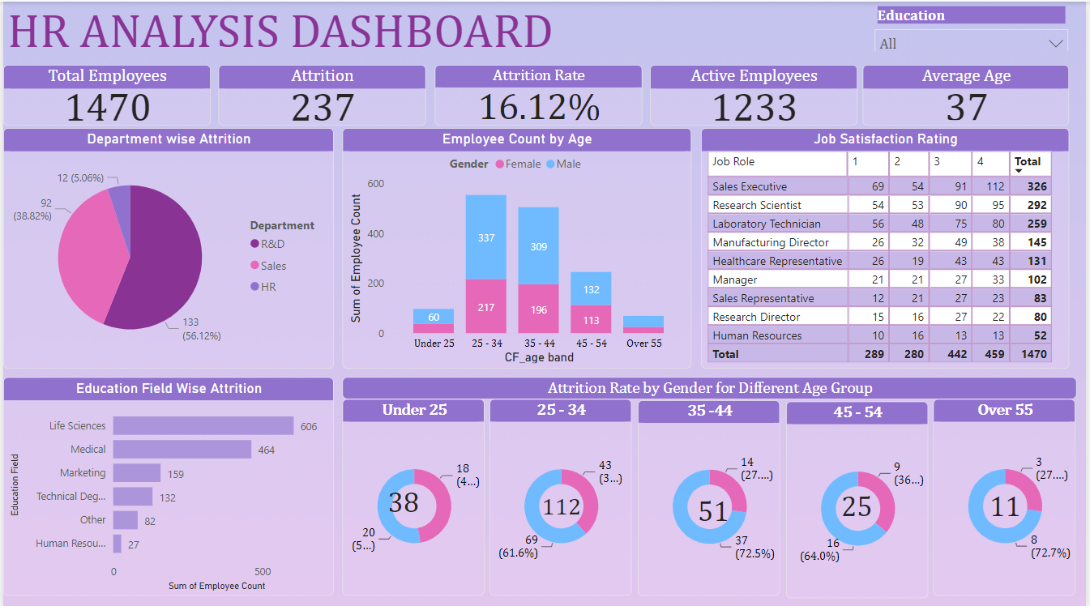

As we explore this intricate data, we'll uncover the stories of the organization's attrition and its employee’s.

I made a dashboard using Power BI wherein multiple **KPIs**are shown at a glance, namely — total number of employees, active employees, employee attrition count and its corresponding rate, Average age of Employee.

Pie chart, bar chart, Matrix, Column chart, donut chart shows distribution of attrition and employees over different factors

I have added a filter for Education to filter out the data based on this

**A Summary of the Workforce:**

- *Employee Count:* **1470**   
- *Active Employees:* **1233**   
- *Attrition Count:* **237**  
- *Attrition Rate:* **16.12%**  
- *Average Age:***37**

**Exploring Attrition Dynamics:**

Attrition by Department:

* Department-wise attrition provides insights into the turnover rates within specific departments of an organization.
* High attrition rates in certain departments can indicate underlying issues such as poor management, lack of growth opportunities, or job dissatisfaction.
* It allows for the development of tailored strategies to improve retention in departments with high attrition rates.
* Comparing attrition rates across departments helps establish benchmarks and set realistic targets for improvement.

Attrition by Education Field:

* Attrition by education field provides valuable insights into how employee turnover varies across different educational backgrounds within an organization.
* High attrition rates in certain education fields might indicate a mismatch between the employees' skills and the job requirements, suggesting a need for better alignment in hiring or additional training programs.
* Insights into attrition by education field can guide recruitment efforts to focus on attracting and retaining talent from education fields with lower attrition rates.

Attrition by Age Group and Gender:

* Analysing attrition by age group and gender provides nuanced insights into the turnover dynamics within an organization.
* Identifies whether men or women in specific age groups are more likely to leave the organization, highlighting potential gender-specific issues or challenges.
* Reveals if certain age and gender combinations experience higher attrition due to work-life balance issues, such as younger women leaving due to family responsibilities or men in mid-career stages seeking better work-life integration.
* Helps in designing tailored retention strategies that consider both age and gender, such as mentoring programs for young female professionals or leadership training for mid-career men.
* Supports the development of more inclusive workplace policies that address the specific needs of different demographic groups, promoting diversity and inclusion

Active Employee’s by Age Group and Gender:

* Analysing active employees by age group and gender provides valuable insights into the composition and diversity of the workforce. This analysis helps organizations understand various aspects of their employee demographics, informing strategic HR decisions.
* Highlights the age and gender diversity within the organization, indicating how well the organization is doing in terms of maintaining a diverse workforce.
* Shows the distribution of employees across different age groups and genders, helping to identify any imbalances that may need addressing.
* Informs recruitment strategies by highlighting which age groups or genders are underrepresented, allowing for targeted recruitment efforts to balance the workforce.

Satisfaction Rate among Active Employeesby Job Role:

* The Satisfaction Rate among Active Employees by Job Role provides valuable insights into how satisfied employees are within different job roles or functions within an organization.
* Different roles can have different requirements, stress levels, and responsibilities, all of which can impact job satisfaction
* Job satisfaction is closely linked to retention rates. Higher satisfaction among employees can lead to lower turnover rates, which in turn reduces recruitment and training costs.
* Satisfaction rates can also reflect the quality of the work environment and culture within different parts of the organization. Areas with lower satisfaction rates may indicate issues that need to be addressed, such as poor management, lack of recognition, or insufficient resources.

**Conclusion:**

As we conclude this journey, we find ourselves at the crossroads of data-driven insights and strategic decision-making. Employee satisfaction, reflected in attrition rates and job role satisfaction, is not just about departures; it tells a story of paths taken, choices made, and futures shaped. By understanding and acting upon these insights, organizations can pave the way for a more engaged, productive, and fulfilled workforce, ultimately driving success and growth in the ever-evolving landscape of work.